Contents
1 Introduction 3
1.1 Purpose and Scope 3
2 Overview 3

9 Further Information 3
9.1 References 3
9.2 Open Issues 3
9.3 Glossary 3

Introduction

Purpose and Scope
This document summarizes the changes done in the client mtm’s to implement enhance search and sort on message store. Also a reference document for 3rd part MTM developers to make the changes in their respective MTM’s to implement the same functionalities.
For a clear understanding of enhance search and sort on message store, please refer section 3.1.

Overview
The prior implementation of search on message store uses global constants to pass conditional variables. The new implementation (Enhance search and sort on message store) proceeded by modifying existing FindL API provided by messaging framework. In order to maintain Binary compatibility, No new APIs were added in the client mtm’s. Also it introduced more global constants to pass conditional variables and other information needed to complete search sort operation.
The proposed changes in the design are the removal of these newly introduced constants and alternatively provide a utility class for the same purpose. Also future extensionality is taken care of in the utility class. These changes were necessary so that the MTM developers get a clear understanding of the design and be able to implement the same without any confusion.

Existing Search Operations:
The existing search implementation makes use of the server side Pure Virtual function Find in CBaseMtm class which are derived by the client mtm’s. The messaging server only keeps track of the basic entry information. Client specific information (for e.g. Message header, message body etc) and the ability to read this lies with the client mtm’s.
The signature for the Find API is
Virtual TMsvPartList Find (const TDesC& aTextToFind, TMsvPartList aPartList) =0;
The above API makes use of TMsvPartList (TUint) to pass information to and fro between the client mtm’s implementation of messaging server Find API.
These flags contain the information about what to search, search modifiers and flags.

TMsvPartList constants prior to advance search and sort implementation
const TMsvPartList KMsvMessagePartNone
const TMsvPartList KMsvMessagePartBody
const TMsvPartList KMsvMessagePartRecipient
const TMsvPartList KMsvMessagePartOriginator
const TMsvPartList KMsvMessagePartDescription
const TMsvPartList KMsvMessagePartDate
const TMsvPartList KMsvMessagePartAttachments
const TMsvPartList KMsvFindCaseSensitive
const TMsvPartList KMsvFindWholeWord
const TInt KMsvMaxFindTextLength

To perform a search operation using existing implementation, the client sets the respective partlist flags and modifiers. These flags are than read in the client mtm’s to perform that specific operation.

For e.g., if the client wants to perform a search operation on the “To” field, He adds KMsvMessagePartRecipient partlist and calls Messaging Server’s Find API from CMsvFindOperation FindL exported API.

Advanced search sort Implementation:

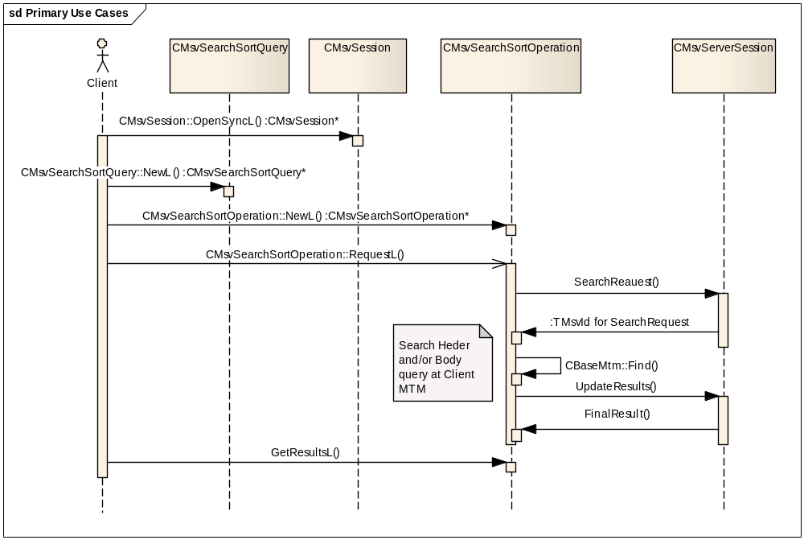
Advanced search and sort is designed to perform complex search (up to 5 levels) and sorting can be specified on the resultant set. The new API’s use Enumerations for clients to specify the message parts to be searched and sorted. Additionally, Wild Card search is also supported.
With advanced search and sort, the clients specify the message parts to search based on the following enumerations.
enum TMsvMessagePart{
EMsvAttachment = 1,
EMsvDetails,
EMsvDescription,
EMsvSubject,
EMsvDate,
EMsvSize,
EMsvPriority,
EMsvMtmTypeUID,
EMsvUnreadMessages,
EMsvNew,
EMsvTo,
EMsvFrom,
EMsvCc,
EMsvBcc,
EMsvBody};

Information about which message parts to search:
To support the combined search and sort operation, the new API’s make use of the existing TMsvPartList flags to pass all information to client mtm’s implementation of Find.
These additional TMsvPartList constants are added in order to pass search specific information to the client mtm’s.

const TMsvPartList KMsvMessagePartTo
const TMsvPartList KMsvMessagePartFrom
const TMsvPartList KMsvMessagePartCc
const TMsvPartList KMsvMessagePartBcc
const TMsvPartList KMsvMessagePartSubject

Utility class passes the conditional variables:
A search sort utility class is introduced to implement advanced search and sort on message store. It contains an integer variable and a pointer variable. The integer value holds the search sort setting flags and the pointer is fr future extension.The client mtm’s get an instance of this utility class object to access the search sort setting flags.

class TMsvEnhanceSearchSortUtil
{
public:
IMPORT_C TMsvEnhanceSearchSortUtil ();
IMPORT_C TInt32 GetSearchSortSetting
IMPORT_C void SetSearchSortSetting (TMsvEnhanceSearchSortSetting aPartList);
void RemoveSearchSortSetting (TMsvEnhanceSearchSortSetting aPartList);
private:
TInt32 iPartList;
TAny* iExtensionData; //Future extension data
};

Additionally it makes use of the following Enumerated constants.

enum TMsvEnhanceSearchSortSetting
{
EMessagePartToSort EMessagePartBccSort EMessagePartSubjectSort EMessagePartSearchSort
EMessagePartLastQueryOption
EMessagePartHeaderLoaded
EMessagePartCcSort
EMessagePartFromSort
EMessagePartSearch
EMessagePartSort
EMessagePartInvalidSortField
EMessagePartBodyLoaded
};

The client mtm’s should make use of the following API’s to complete the operations in the respective mtm’s.

GetExtensionData ( ) defined in CBaseMtm. This gives an access to the TMsvEnhanceSearchSortUtil class instance.

Additionally, GetSearchSortSetting ( ) and SetSearchSortSetting ( ) defined in
TMsvEnhanceSearchSortUtil class.
The following changes are needed in the following API’s in the respective client mtm’s.

LoadMessageL ( )
FindL ( )
DoFindL ( )

LoadMessageL ( )
By default, the LoadMessageL ( ), loads the all the message parts. This is unnecessary while searching and sorting as it increases the performance overhead.

Get an instance of TMsvEnhanceSearchSortUtil class by using GetExtensionData ( ) in the respective client MTM’s.

An instance of this class is created when a search sort request is issued.

If the instance is NULL than LoadMessageL behaves in the normal. I.e. loads all the message part.
If it’s not NULL than do not load any of the message part. This will be done in the FindL API depending on search sort criteria.

FindL ( )
In FindL ( ) API, get the search sort criteria by getting an instance of TMsvEnhanceSearchSortUtil class object by using GetExtensionData ( ).

Access the searchsortsetting Flag by calling GetSearchSortSetting ( ) API of TMsvEnhanceSearchSortUtil.
This returns a Tint variable and contains the search and sort setting flags.

In the FindL ( ) API, Load the, message header or body depending on the header search or body search.

Use SetSearchSortSetting API and set one of the following flags.
EMessagePartHeaderLoaded
EMessagePartBodyLoaded
This is to ensure that the header or body is not loaded twice if more than one search query options are specified on header or body.

E.g. TMsvEnhanceSearchSortUtil* setting = TMsvEnhanceSearchSortUtil*) (GetExtensionData ());

// Get Advanced search sort setting flag
TInt32 searchsortsetting=searchsortutil->GetSearchSortSetting ();

if (!(searchsortsetting & EMessagePartHeaderLoaded))
{
// Load the header
searchsortutil->SetSearchSortSetting(EMessagePartHeaderLoaded);
}

1) Search operation
The following flags are defined in mtmdef.h identify message parts to search.
While searching use the following vaues to find the search criteria.
const TMsvPartList KMsvMessagePartTo
const TMsvPartList KMsvMessagePartFrom
const TMsvPartList KMsvMessagePartCc
const TMsvPartList KMsvMessagePartBcc
const TMsvPartList KMsvMessagePartSubject
Example code for searching
In the client mtm’s, the flag values can be extracted using aPartList argument of the Find API
TMsvPartList ClientMtm :: Find(const TDesC& aTextToFind, TMsvPartList aPartList);
The search can be performed based on the status of these flags.

The below code snippet shows the sequence of events for a search operation in client mtm’s
It shows the search being performed on the header field.
#if (defined SYMBIAN_MESSAGESTORE_ENHANCED_SEARCH)
if (aPartList & KMsvMessagePartTo)
{
FindInMessagePartRecipientL (aTextToFind, aPartList, aHeader.ToRecipients ())? foundList|=KMsvMessagePartTo: foundList;
}
else if (aPartList & KMsvMessagePartCc)
{
FindInMessagePartRecipientL (aTextToFind, aPartList, aHeader.CcRecipients ()) ? foundList|=KMsvMessagePartCc: foundList;
}
#endif

2) Sort Operation:

There is no sorting done in the client mtm’s. To implement sorting the sort data is copied first and than the sort is performed. MTM developers need to use SetExtensionData ( ) to point to the field being sorted on.
e.g.
Eg TMsvEnhanceSearchSortUtil* setting = TMsvEnhanceSearchSortUtil*) (GetExtensionData ());
// Get Advanced search sort setting flag
TInt32 searchsortsetting=searchsortutil->GetSearchSortSetting ();
The below code snippet shows the sequence event while performing sorting.

if ((searchsortsetting & EMessagePartSort ) || ((searchsortsetting & EMessagePartSearchSort) && (searchsortsetting & EMessagePartLastQueryOption) && (retList)))
{
if (iHeader)
{
if (searchsortsetting & EMessagePartToSort )
{
SetExtensionData ((TAny*) &iHeader->ToRecipients());
}
else if(searchsortsetting & EMessagePartCcSort)
{
SetExtensionData ((TAny*) &iHeader->CcRecipients ());
}
else // if the mtm doesn’t support the message part to sort
{
searchsortutil->SetSearchSortSetting(EMessagePartInvalidSortField);
}
}
The data is copied by setting SetExtensionData ( ) pointer to the field on which the sorting is specified.
Few conditions should be checked before setting the pointer.

Note:
Not all mtm’s support all the message parts. For e.g. sms does not contain Cc, Bcc
In these conditions, EMessagePartInvalidSortField flag should be set.

The following flags should be used to check for the condition.
For only sort operation, check if EMessagePartSort flag is set in aPartList argument

For search and sort operation, EMessagePartSearchSort flag will be set.
Additionally, since up to 5 levels of search options can be specified, the data should be copied only when the last of the search operation succeeded.
To know if it is search and sort operation, EMessagePartSearchSort flag can be used.
To find if it is the last of the query operation, EMessagePartLastQueryOption flag should be checked.

The result of the last search operation can be obtained by obtaining the result of the search operation.
I.e. FindInMessagePartRecipientL (aTextToFind, aPartList, aHeader.ToRecipients ())? foundList|=KMsvMessagePartTo: foundList;

Here foundList contains the result of the last search operation.

Only when all the above 3 conditions evaluate to true, the SetExtensionData should be set to point to the field being sorted.

In summary, the TMsvPartList flag is used to check for the various conditions while performing the search sort operations in the client mtm’s.

Further Information

References
No. | Document Reference | Version | Description
[1] | Enhanced Search Sort API How-To Document | 1.0 | Provides information about how to implement advance search sort operation.
[R2]

Open Issues

Glossary
Term | Definition

